**Inventory System Survey Report (Zeeshan General Store)**

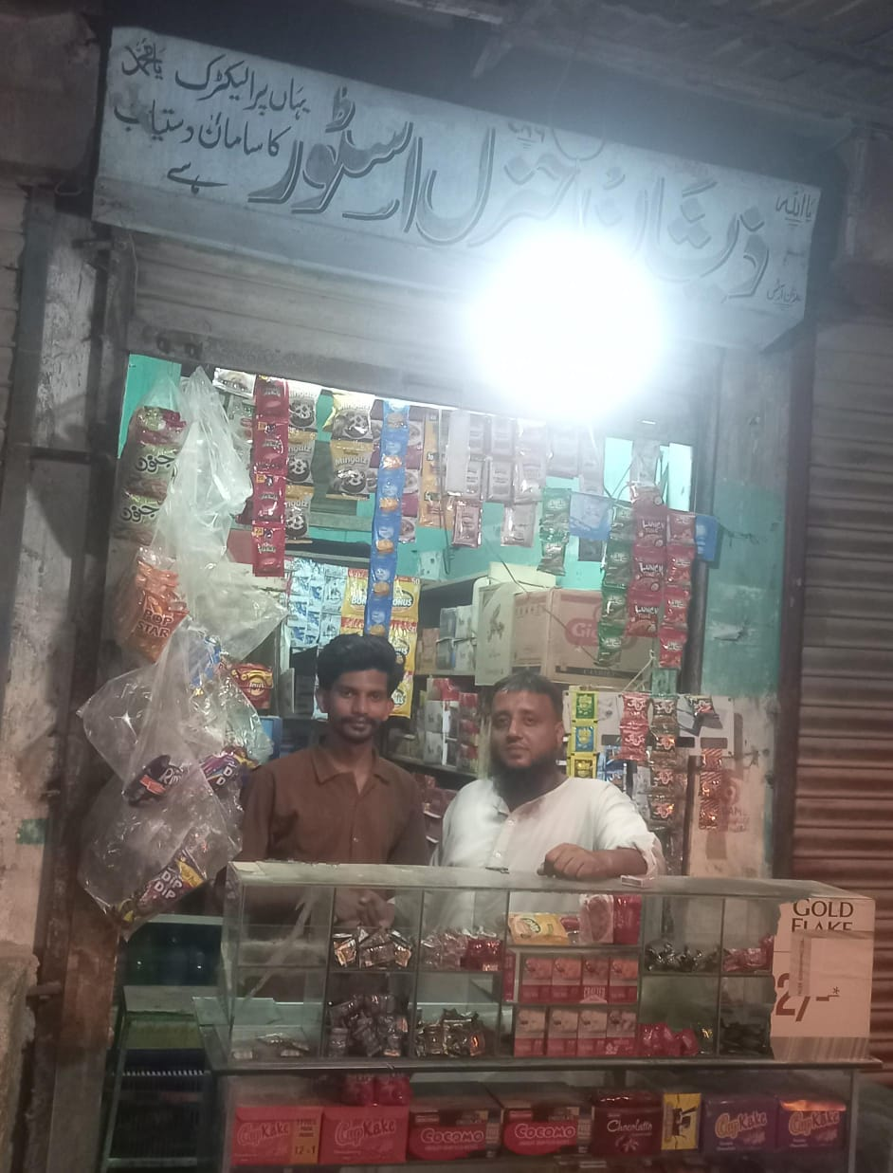

**1. What type of shop/business do you run?**  
General store (daily household items, grocery,cold drinks, beverages etc.)

**2. How many products/items do you usually keep in stock (Approximately)?**  
Around 300–400 items.

**3. How many employees manage your inventory?**  
2 employees (including owner).

**4. How do you currently track your inventory?**  
Mostly through paper register and manual checking.

**5. How often do you update stock records?**  
Only during purchase or sales.

**6. How do you record sales and purchases right now?**  
Sales are recorded in a manual register or sometimes just noted in khata. Purchases tracked from supplier bills.

**7. How do you know when stock is running low?**  
By manually checking shelves or customer demand when item runs out.

**8. What problems do you face with your current inventory system?**

* Sometimes stockouts when fast-selling items finish.
* Over-purchasing of slow-moving items.
* Manual errors in register.
* Difficulty in tracking expiry products.

**9. How much time do you spend on stock management daily/weekly?**  
About 1–2 hours daily.

**10. Have you ever lost sales due to inventory issues?**  
Yes, when popular items like milk, bread, oil, or snacks are out of stock.

**11. Do you face difficulty in tracking product expiry dates or batches?**  
Yes, especially in dairy products, biscuits, and soft drinks.

**12. Do you find managing your khata of suppliers and customers difficult?**  
Yes, manual khata sometimes gets misplaced or calculation mistakes happen.

**13. What features would you like in an inventory system?**

* Low stock alerts
* Expiry tracking
* Reports (sales, profit/loss, stock valuation)
* Supplier & purchase management
* Customer credit (Khata) management

**14. Would you like the system to be offline, online (cloud-based), or both?**  
Both (offline for shop, online backup for safety).

**15. Are you currently paying for any software/service? If yes, how much?**  
No, currently not using any software.

**16. What budget range would you be comfortable with for an inventory system?**  
Low budget, around 1,000–2,000 PKR per month.

**17. Do you prefer a one-time purchase or a monthly subscription?**  
Prefer monthly subscription (easier to manage).

**18. Do you or your staff feel comfortable using mobile apps or computers for inventory?**  
Yes, more comfortable with mobile apps than computers.

**19. What type of reports would help you in decision-making?**

* Sales trend
* Top-selling products
* Slow-moving products
* Profit/loss
* Stock valuation

**20. How often would you like to receive reports?**  
Weekly or monthly.

**21. Are you planning to expand your business in the future?**  
Yes, plan to add more products and possibly open a second branch.